ABC Parking Management System – User Guide

Table of Contents

1.Introduction 1

2.Getting Started 1

3 Roles and Access 1

4.Common Tasks(All users) 1

5.Management Registration 2

6.List of services………………………………………………………………………………………………………...7

7.Reserve a Parking…………………………………………………………………………………………………10

8. Troubleshooting 13

1.Introduction

Welcome to the **ABC Parking Management System**! This guide will help you navigate through the application and make the most of its features. Whether you are registering for the first time, managing company parking allocations, or booking a parking space, this guide has you covered.

2. Getting Started

To start using the application, open your web browser and navigate to the application’s URL:

👉 <http://localhost:8080/com.Team7Project/adminRegister.xhtml>

3. Roles and Access

The system is role-based. Users only see functions needed for their role.

4. Common Tasks(All users)

***Management****: System administrators who oversee company accounts, allocate resources, and monitor parking activity****.***

***Members:*** *Companies that control their assigned pool of parking spaces, set availability, and define pricing.*

***Customers:*** *End users who book and pay for parking spaces at ABC Parking.*

5.Management Registration

#### Step 1: Open the Registration Page

* On the login page, click the "Register Here" link.

#### Step 2: Fill in the Registration Form

* Provide your details: first name, last name, email, password and confirm password
* I accept the Privacy Statement.
* Click the “Register button”.

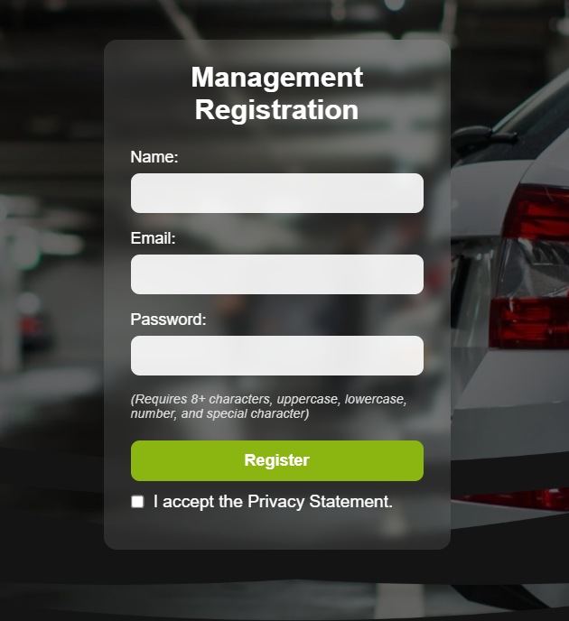

#### Step 3: Success

After completing registration, user will be redirected to the login page.

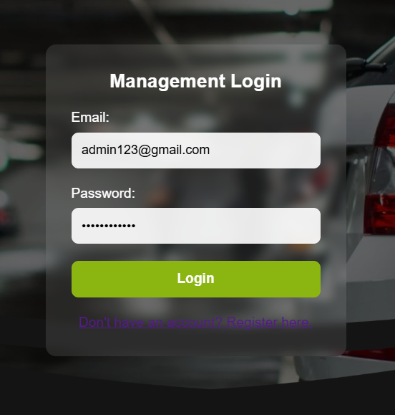

Admin can manage both members and parking.

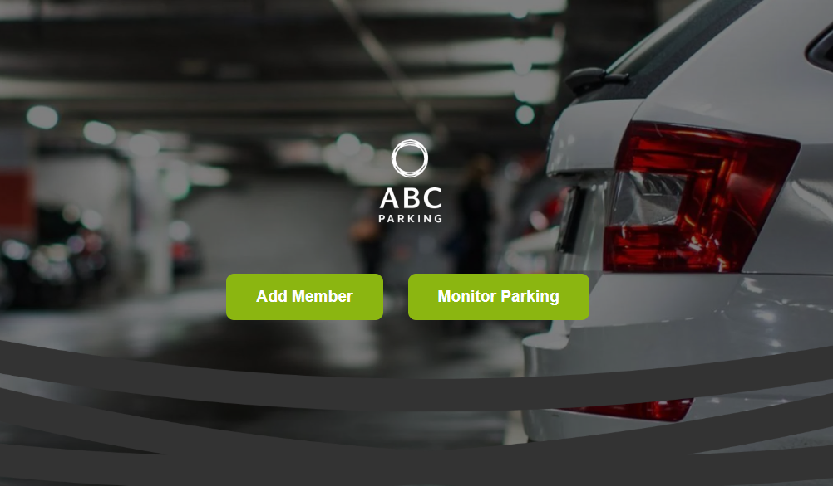

CRUD operations can be performed on member details.

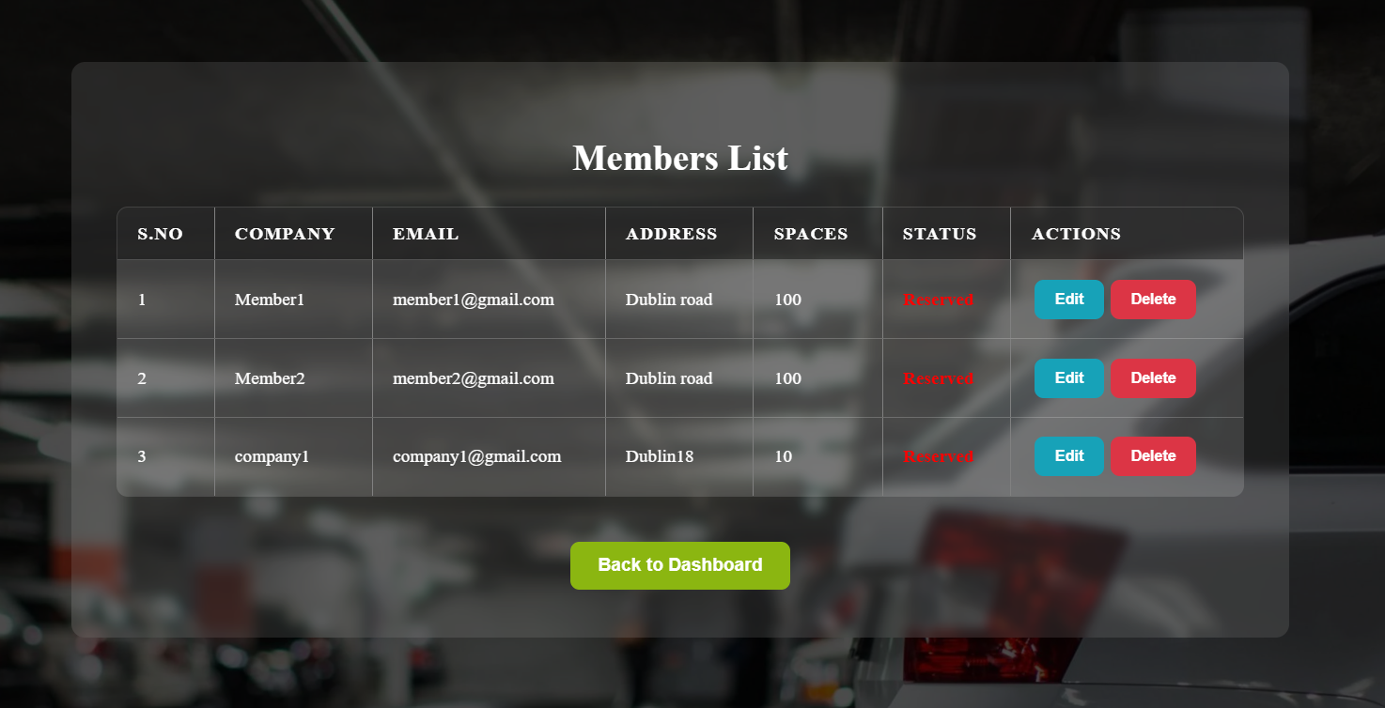

The member can log in using the ID that was registered by the management.

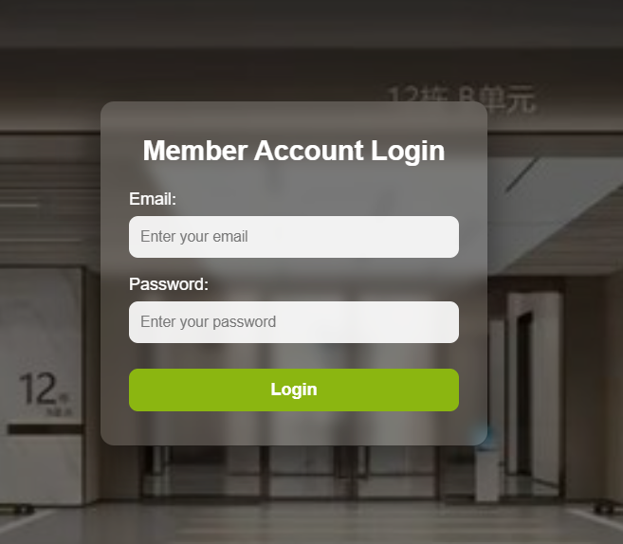

After login, the member dashboard will be displayed, and member can manage their own pool of parking spaces and can set the prices as well.

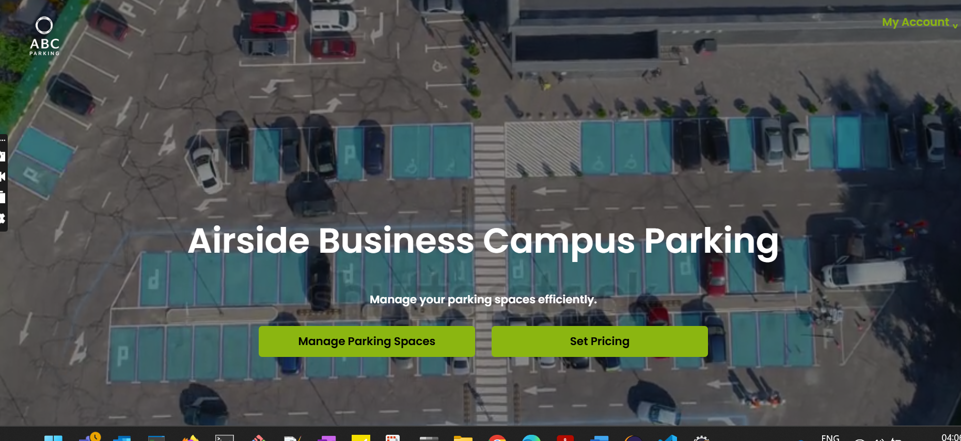

A member can add parking spaces, perform CRUD operations on them, and define related processes.

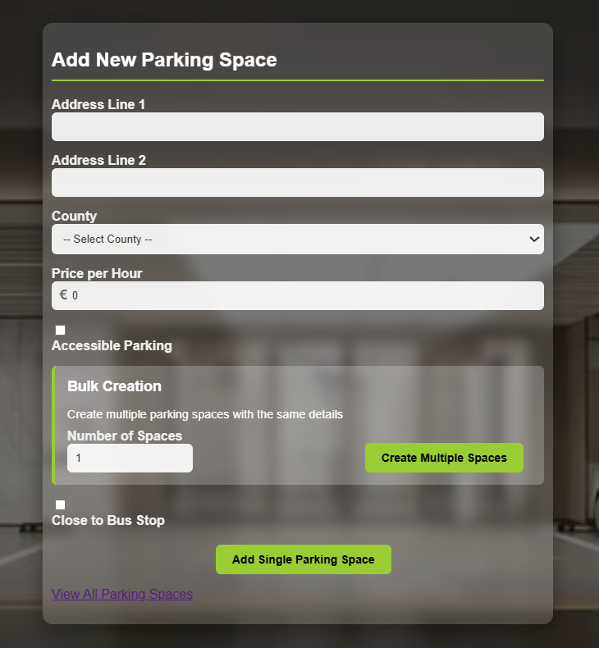

This section displays a list of all available and occupied parking spaces.

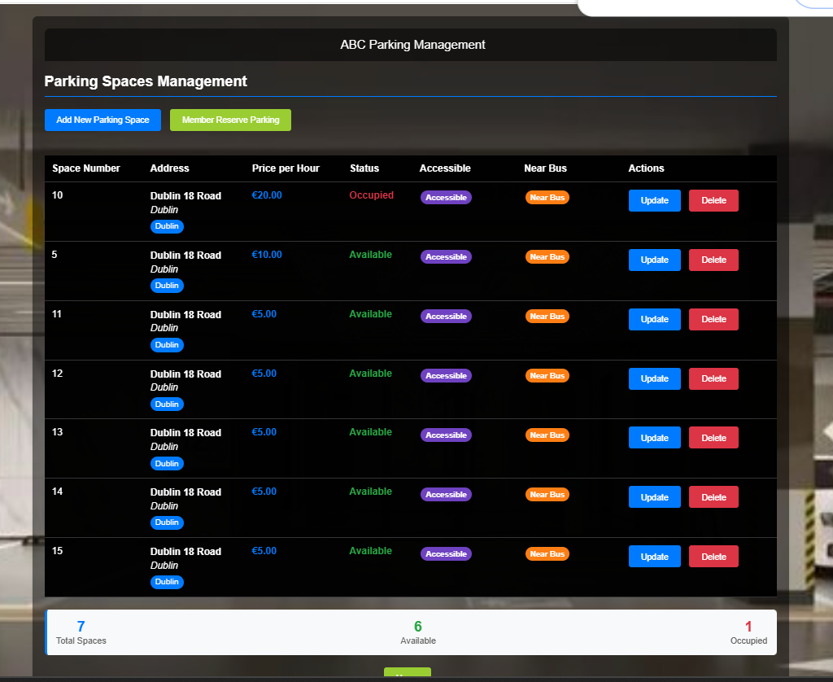

A member has the ability to update parking spaces.

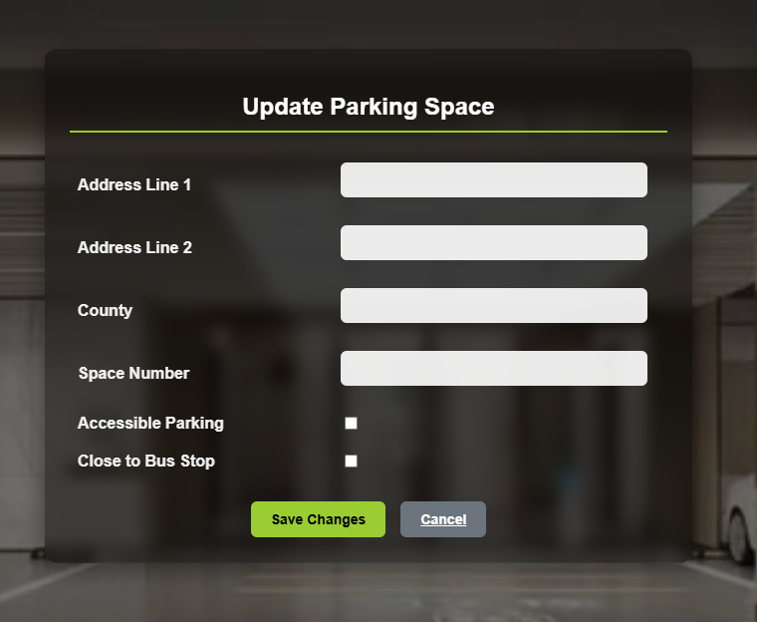

Members can reserve designated staff spaces.

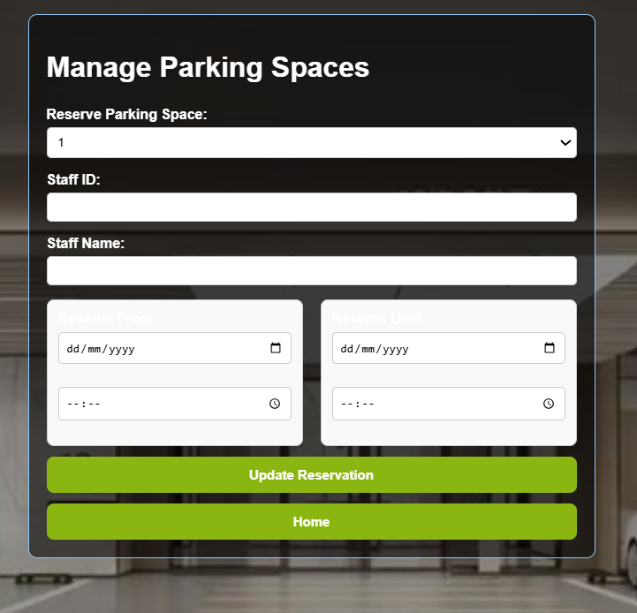

6. List of Services

Below Services are provided as part of UTCS Reservation System.

***For customers:*** *Create an account, search & book parking spaces, and pay online via PayPal; can request accessibility-related options (e.g., spaces close to the airport shuttle stop).*

***For member companies:*** *Become ABC Parking members to contribute their allocated spaces, set prices, and reserve spaces for staff or make them public for customer booking.*

***For management****: Manage companies and their office/parking allocations and monitor parking usage, with role-based access controls and a user-friendly UI.*

Customer landing page where users can register and search for parking spaces.

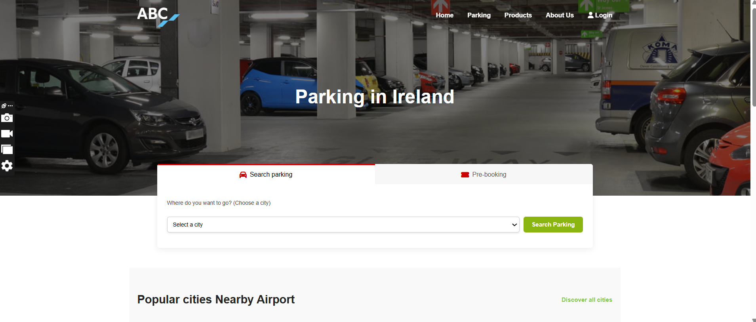

Customers can create an account, register, and search for parking spaces.

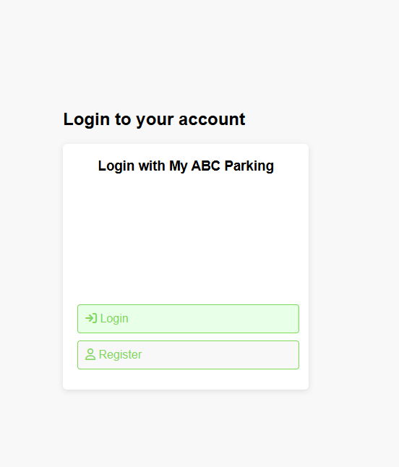

Customer Register & Login.

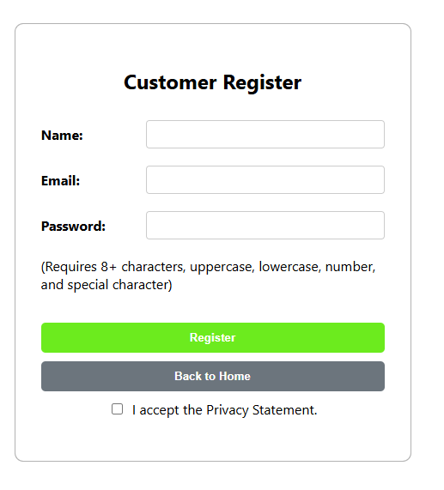

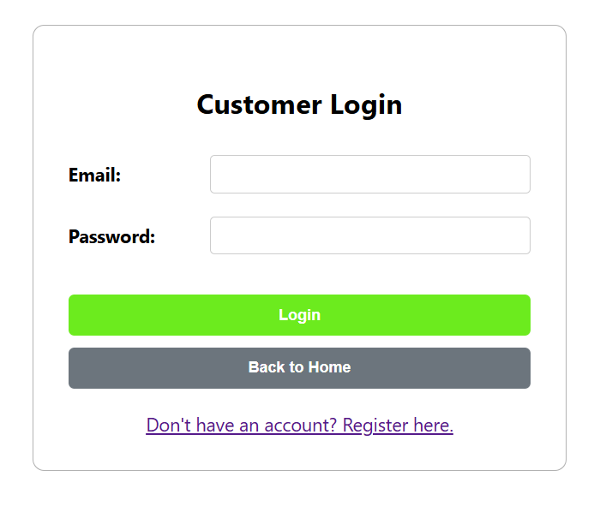

7. Reserving a Parking

#### Step 1: Search for space based on maximum price ,Address and County.

#### Step 2: Select require parking based on your requirements – Click Book Now

* Choose the date and time slot
* Click the "Reserve" button.

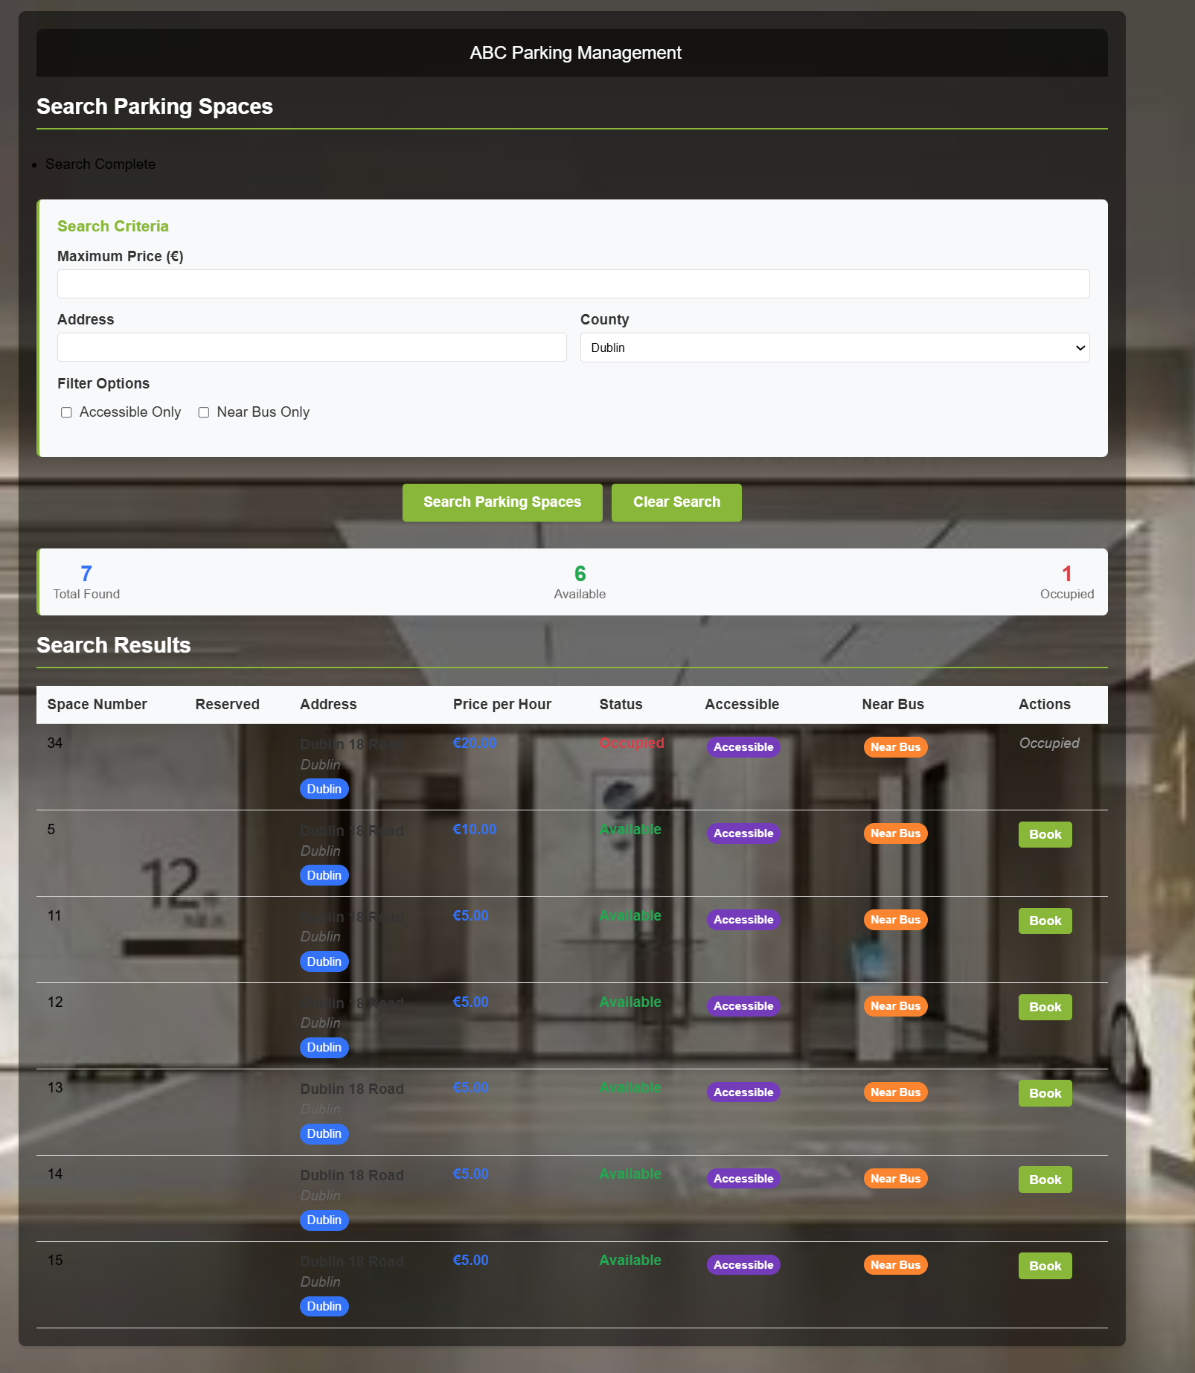

Customer can search for the available parking spaces and can add it to the cart .

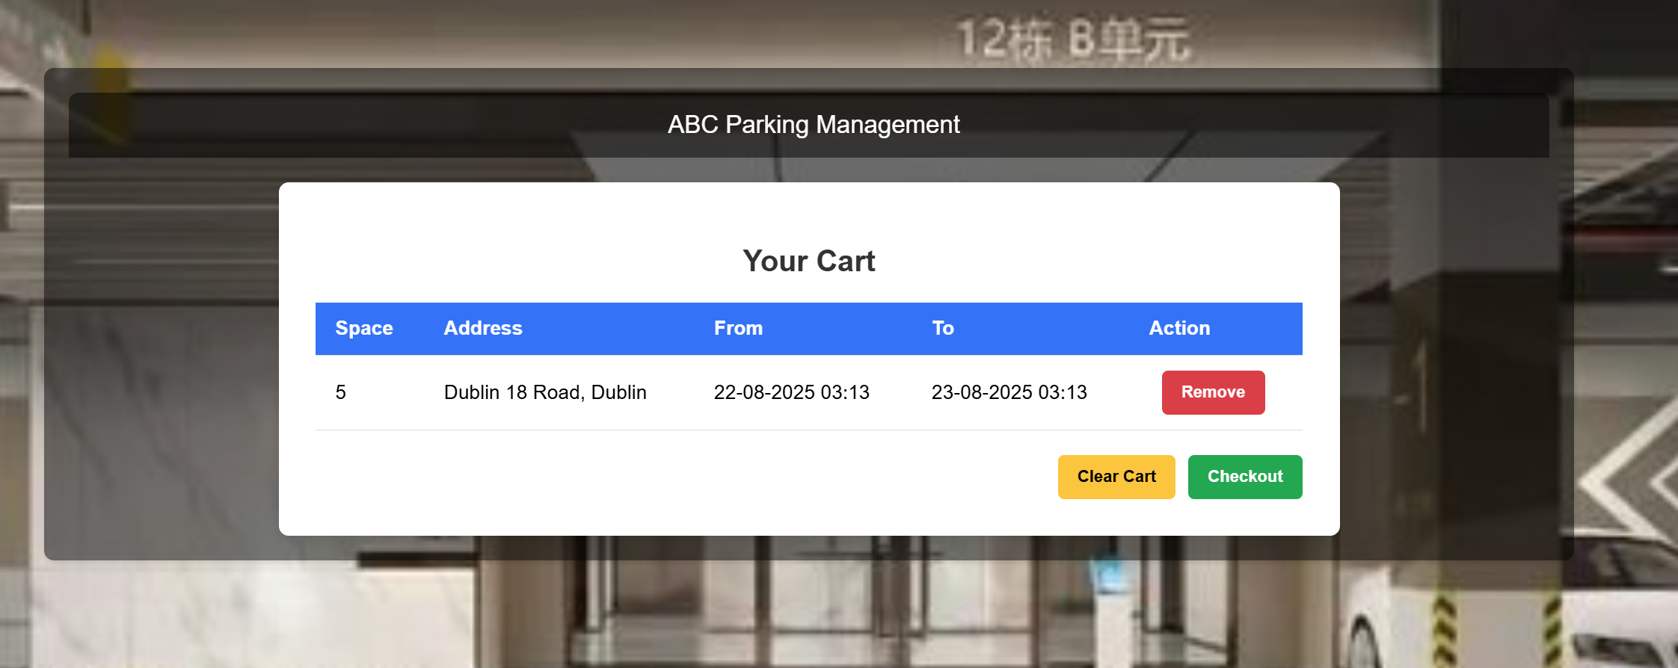

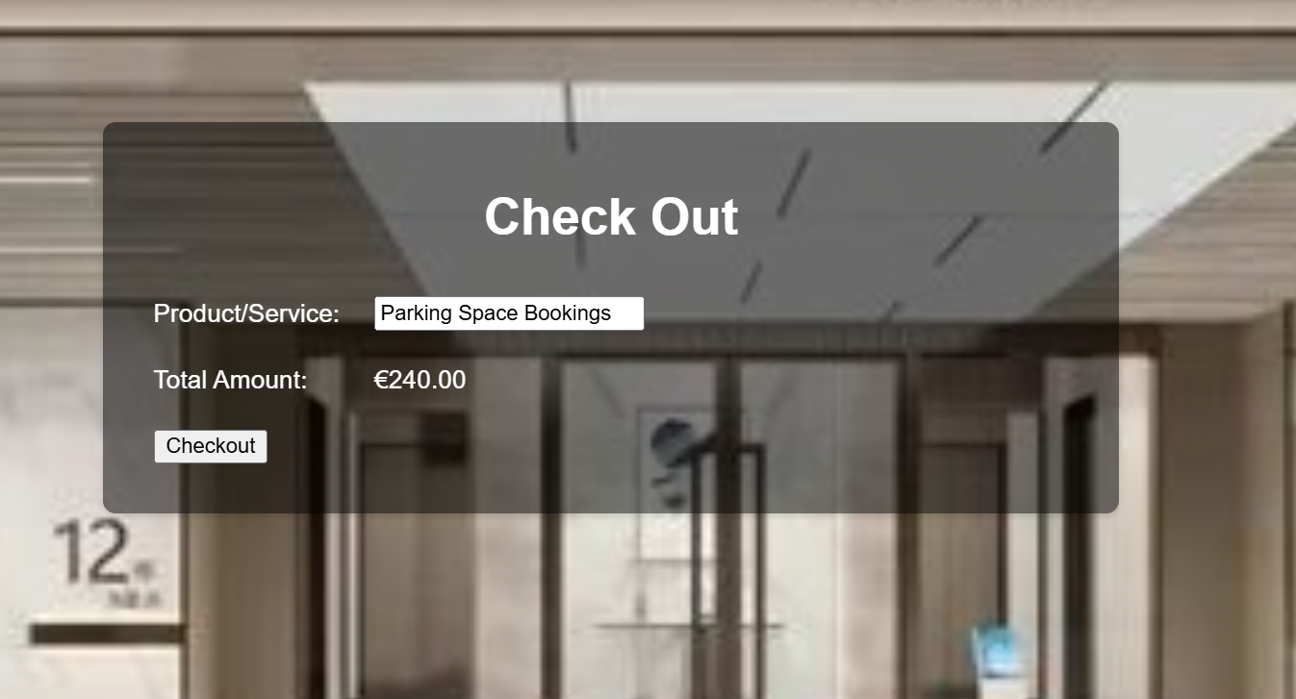

#### Step 3: Automatic redirect to PayPal Payment page.

* You will be redirected to PayPal's sandbox for payment.
* Log in with your sandbox PayPal account and complete the payment.

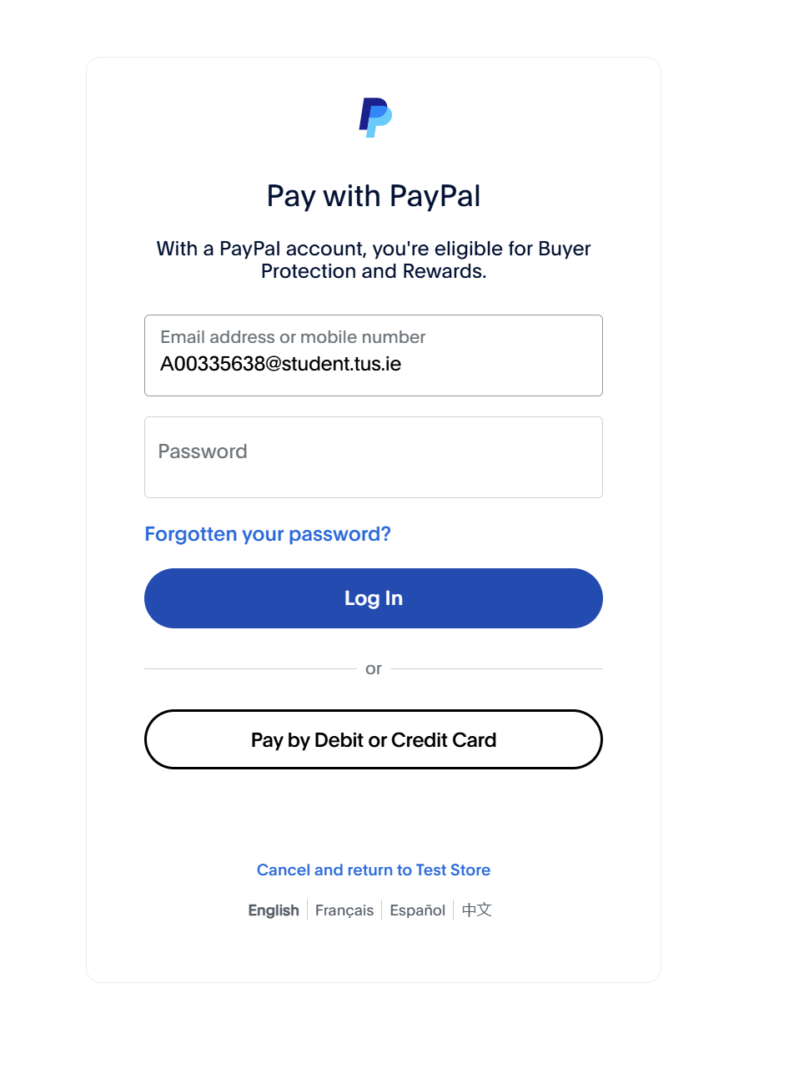

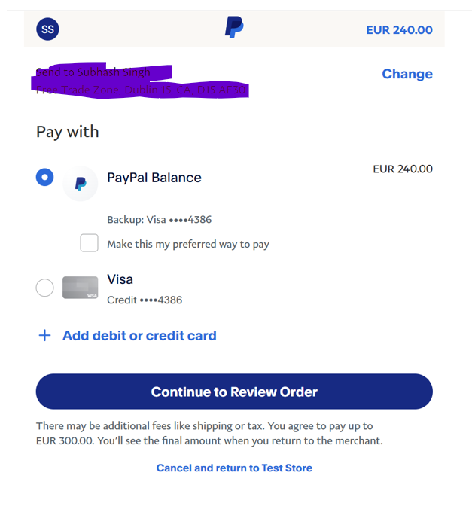

#### Step 4: Successful Booking Completion message.

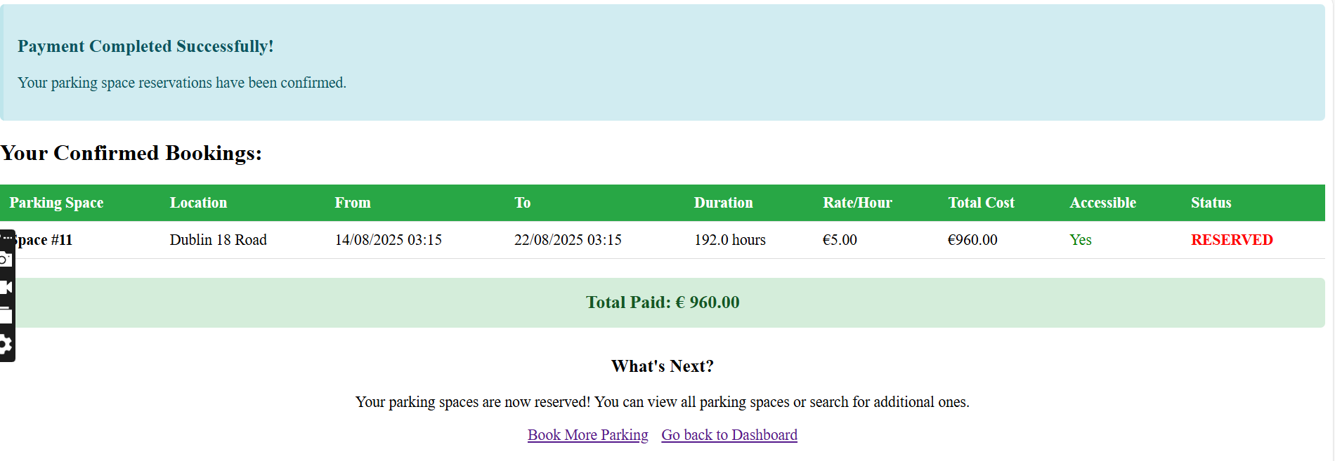

#### Step 5: In case of cancellation ,payment will be failed.

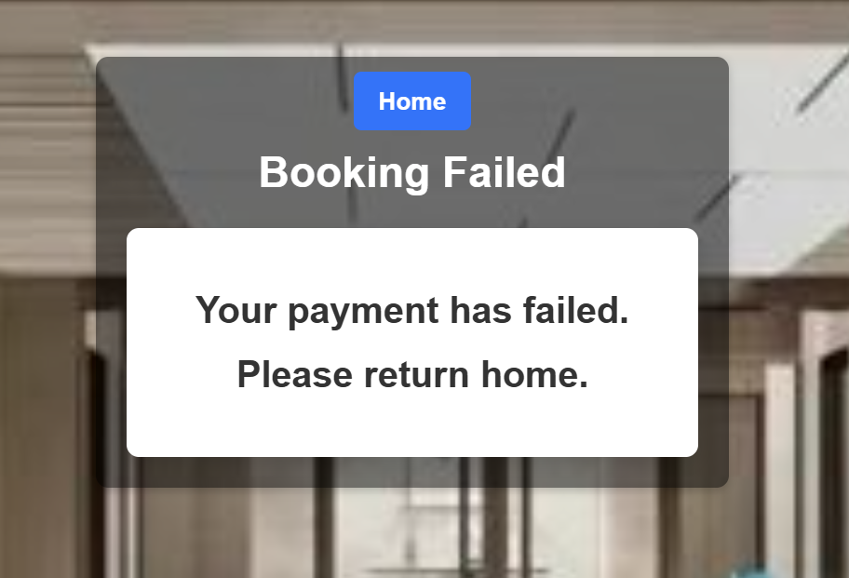

8. Troubleshooting

If you encounter any issues while using the application, consider the following steps:

* **Clear Browser Cache**: Sometimes old data can cause issues. Clearing the cache may resolve them.
* **Check Internet Connection**: Ensure you have a stable internet connection.